Paypal Instructions

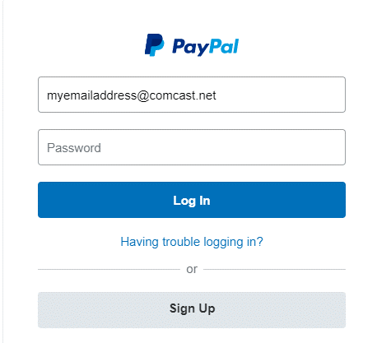
- Login to your PayPal account
(If your payment source, checking
account or credit/debit card) are
linked to your account, proceed
to #3).

- Link your checking account to your PayPal account.

- Press the ‘Send and Request’ button at the top of the page.

- In the “Send Money” Box,
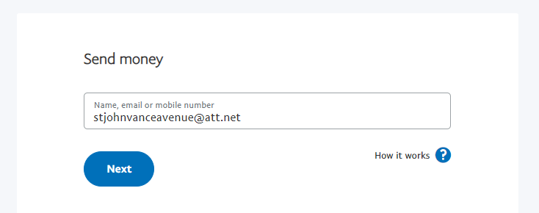
Key in St. John’s email address:
stjohnvanceavenue@att.net

- Press the NEXT button

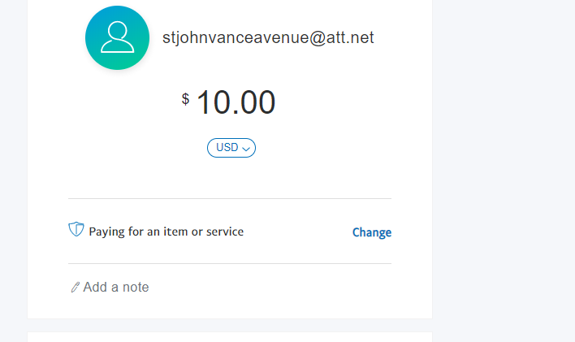
- Fill in amount to give.

- Press the Continue key

- You will see ‘Paying for an item or Services’ below the amount.
In the “Add a Note” box, key the reason of this payment (Tithes, Church’s Anniversary.)
The Change option is at the right of the page. Press Change.
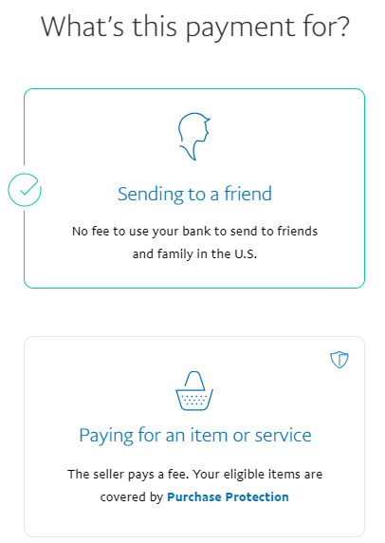
- Choose ‘Sending to a friend’.

The option will change to
‘Sending to a friend’.

- Choose your checking account as the payment option.

- Press ‘Send Payment Now’.

There will be no transaction charge
if you follow these instructions.

